**Project Development Phase Delivery of Sprint – IV**

|  |  |
| --- | --- |
| Date | 11 November 2022 |
| Team ID | PNT2022TMID50609 |
| Project Name | IoT Based Safety Gadget for Child Safety Monitoring and Notification |

**NEO-6M-0-001 GPS MODULE**

The NEO-6M GPS receiver module uses USART communication to communication

with microcontroller or pc terminal. It receives information like longitude, latitude, altitude, UTC time etc.NEO-6M GPS module that can track up to 22 satellites and identifies locations anywhere in the world.

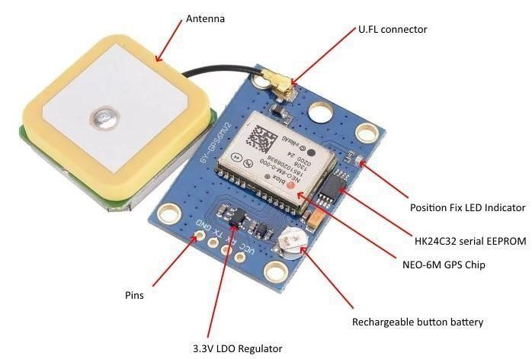

**Figure: NEO-6M-0-001**